

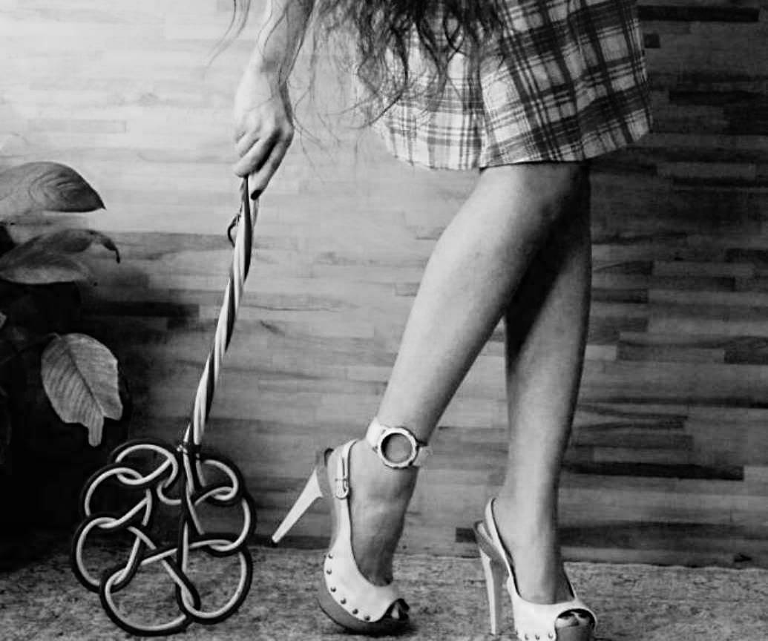

This is a taste of Giovanna Esse's Anthology: ITALIAN WOMEN’S EROTIC SINS - ©
Translated by C. Cassels.
For info contact the author.
All rights reserved.

SOURCES

a) - Femdom
The dominatrix woman has the characteristics that we would all like in general, especially when too often we demolish and diminish our abilities.
The important thing is to remember that being born dominators can be a luck but it’s not said that one can learn to become one!
Some advise to have more faith in yourself:
1 - Be spontaneous, this has always been the best method for self security.
2 - Always listen to your partner carefully, giving him advice only after having heard his reasons and desires
3 - Tolerate and appreciate thoughts different from your own because they anyway provide a different vision of the world, that can enrich you
4 - In intimacy, change roles and pass, every once in awhile, from prey to predator
(from the web)

b) - The “Dark Lady” is a seductive, manipulative and while she isn’t necessarily evil, she is

angerous anyway. She is prejudiced and sensual, unfaithful and damned; however it isn’t uncommon to find female portraits in which ambiguity is only a produce of a distorted male vision.
(Anonymous)

1

“Ejaculation is a tragic moment, more awaited and more feared. After which the scene loses, to me, any fascination and any attractiveness. As if the colourful headlights of the stage turned off, leaving only the false and grey backstage.
Then, my groin, which first boiled like a pressure cooker, that small and powerful sexual apparate, practically ceases to exist. Its as if in place of the willy and the scrotum there is nothing any more: emptiness! The pelvic zone that had guided my brain, possessing it and directing it like a irrefutable helmsman, loses all its power. Even for my nervous system that doesn't feel its presence any more!”.

To present himself is Ludovico, 58 years of age, husband of Janeth, only 39.
Ludo is a perv.
In a intimate and secrete corner of his sexuality he hides desires and pulsions that cannot be defined differently.
Destiny has made him meet Janeth and he couldn’t have asked for more in life. A

stupendous, affectionate woman, obviously and obligingly in love. Janeth has given him her beauty, her dedication, her youth and, finally, a beautiful baby.
After some years of peaceful relationship, on a tranquil saturday afternoon, Ludo asked his wife if she was up for playing a bit; she answered “Let’s try!”... Since that day, a perverse universe slowly disclosed to the married couple who, in secret, from time to time become lovers and accomplices.
In the years when Ludo thought he was reaching a slow and placid peace for his sense, he began one of the most turbulent and demanding paths of his disrupting erotism.
Janeth too had an obscure side: Ludo couldn’t have known it, they had never deepened the subject. Now he had to suffer it, relishing and crawl in his submission.

The game began as a simple inversion of roles.
Then, after a few days it was Janeth to penetrate her husband’s hole with a rather unusual object, the handle of a hairbrush. Her first anal action

didn’t only mean to Janesh a moment of transgressive pleasure but a real take of position, in the side of their erotic coexistence.
At times, if the moment, the period and the excitement permitted it, the wife would make the husband understand that she “wanted” it and he, immediately became slave and prone, wiggling happily, waiting to be mistreated and, when needed, sodomized.
Following this path, as well as penetrating him with increasingly large and sophisticated objects bought on the internet, Janeth treated him as a pleasure slave: forcing him to drink her liquids, to lick her shoes, pummeling him often with whips and sticks. The hits, at the beginning only reserved for the bottom but then she started to feel pleasure in hitting him with the stick on his legs, soles and on the belly. When she was particularly horny, when the meeting didn’t happen any more as a game but as vengeance, the lady would hit him on the penis or on the balls… in these cases, poor Ludo would suffer for days, fearing even for his health. Unfortunately, remembering the received pain turned him on even more and made him more willing to receive more.

Our friend was really ungifted and in those periods of deep prostration, his penis became even small and inconsistent, completely inadequate for penetration.
After having buried the tantrums and repercussions, when the wife had finished with him, Ludovico could only give himself pleasure alone, under the Janeth’s humiliating and entertained look.
Naturally the difference of age, with time, made even more difficult for the woman to have a satisfying intercourse strictly from a female point of view. Consequently, with the husband’s agreement, they organized some dates with occasional young partners, often then rather awkward.
Ludo was in charge of recruitment. He registered on various websites for singles and couple’s dates, to accurately chose the potential partners. The fact they were gifted of penises we could define “superb” was certainly a well accepted factor for Janeth’s horny holes. But she would find the greatest pleasure in the turned on a blissful but suffering look of her husband.
Ludovico, combatted by nature, plastered himself

in desire and bitterness. Desire, because he also liked cock and bitterness because it was always a subtle pain to see his wife “dug” and often impaled by those gross strangers.
Then, the lady dropped her eye on a teacher colleague that fancied her. She evaluated him carefully and decided to make him her lover.

2

Ludovico had had to follow the development of the relationship between his wife and lover: it was a condemnation!
He knew of the advances that she received and knew the behaviour she adopted: she was at times complementing and available, others rough and difficult.
There was no love between the two!
When she decided to sum things up, she did it it the most awful of ways: she made things clear for both of them, and did so in a mortifying manner for Ludo already from the first approach.
Even Ciro, their friend, had to surpass a hard trial. He was younger than her, he had had a couple of girlfriend… let’s say a “traditional” life. His

almost innocent attraction towards the pretty lady could have evolved in an unaccomplished passion or in a brief sentimental history. Instead, Janeth made of it a mix between sex and perversion.
Perhaps, if Ciro had known before what he was falling into, he would have avoided it, fearing the consequences of so much lust, but she was able to cook him to the right point: in about six months, she built around him a net from which he would have difficulty escaped.
The first real encounter happened in a Motel. Ciro got a room and took his conquest. Ludo already had booked a room on the same floor.
When the caresses became more intense and Ciro’s penis more swollen, Janith candidly explained to her possible lover that her husband was only a few meters away and she could have called to describe to him the evolution of that forbidden contact. The guy was too horny to pull back… after all, Ludo’s wife in the past few years had lost any inhibiting break. Since her new, perversed, volitive dimension had been found, she had become a truly irresistible slut.
She got naked, languid and provoking; Ciro already had the age when the phallus does not

forgive and proved himself gifted beyond any expectation. When, after the second eiacultaion, Ciro felt calmer, Ludo, who had been listening to everything, was allowed to enter.
Once naked, a rather obscene sight, he had to clean the wife, thrown on the sofa, from any trace of male semen. In other words, with his tongue he had to taste Ciro’s sperm who, unready for such lust, observed the scene with disbelief.
Even Janeth’s ecstatic and triumphant expression struck him; something in his subconscious warned him that she was a woman to fear.

3

“As I was saying, my mind (that tends towards deprivation) caused me adrenaline discharges and unrepeatable emotions, during the “awaitings”... after coming, pleasure falls in an instance, and only the “pure” sense of what I am living remains: shame, frustration, pain. The horrible thing is that, only after a few hours, when I return excitable let's say, I begin to relish again, precisely from the sense of mortification of

prostration that has been inflicted on me. A true psychic trap that condemns you to bare… infinitely.”
With time, the three lovers became increasingly involved. Janeth, in the height of her hormonal tempest, began to experiment a form of constructive, ideal pleasure. Before real intercourse, in the past, excitement would come by contact, by stimulating her erogenous points; now she felt blood rising to her temples by imagining what to make her husband do.
The mere comparison between the penises, for instance: Ludo’s “little shy snail” and the undesirable pole of your Ciro, exalted her senses and made her greed explode inside.
Poor and damned Ludovico, relished and suffered the disastrous confidence between the two lovers. He didn’t worry about their feelings, although after all he also didn’t feel loved: years of matrimony and pleasure to share with Ciro, making their union more like a respectable society.
The young man, finally, was the living confirmation of an old saying: Who hasn’t done it

before, will do it later…
Southern, from a wealthy family, religious ex altar boy, in the height of his vigor and finding himself in the role of “stallion” for that hot and likable “MILF”. The betrayed and lascivious husband disturbed him initially… with time, all that submission ended up tickling the newborn lust.
So, even Ciro met deprivation and slowly lost himself in it without too many remorses.

4

As happens inside complicated minds, Ludovico elaborated a plan.
He would have never had the courage to break the erotic enchantment, which fascinated him more than anyone. However, Ciro deserved a lesson, he felt too self-assured, starting to master around both in his house and with his wife.
Luck permitted him to find an accomplice: Gino!

Gino: for the web “Sologi70”, in life had experience and was reaching his sixties; he also had a younger companion (but Ludo only

discovered this later). It seemed to Ludovico that he had experience in complicated menage and, very useful fact, he lived in a nearby village.
In his communication with Gino, Ludovico mentioned little of his wife, he wanted to know well who he could have taken home… but then, the hastiness with which the man made himself available to any of his desires started to turn him on.
He found the courage to meet the old man and discovered with pleasure that he was a distinct person, with manners, who didn’t worry about hiding his inclinations. A true executioner: precise, punctual, cold.

Notwithstanding he was more of a cuckold than a masochist, Ludovico immediately accepted the man’s hasty manners, who dominated him at once, even from a mental point of view. In the first session, without any problems, he did him in the ass, in three ways: first with a very flexible stick, then with his penis which remained well pompous all the time. Finally, he forced him to drink all the seemen without wasting a drop.
Gino took some eloquent photos of the

happenings but, with extreme discretion using Ludo’s phone. The only commitment that he asked him, with no mid terms, was to show the entire session to his wife. Ludo intimately release of his jailer's shrewdness:
-He’s the right man!- He told himself.

5

“It wasn’t enough for you, was it?” said Janeth, after turning the light off. Ludovico, after some indecisiveness, had showed her the photos of his “sins”. The explicit images passed on the Tabled under his wife’s perplexed face.
“I couldn’t help it… that man is so decisive that I my legs become jelly… I feel like a robot; a salve with no will. If I have to say it all…” Ludo paused as he spoke lowly in the large bed.
“Everything, I won’t allow any more secrets!” said his wife, extremely irritated. Already in another occasion she had noticed that malicious cowardness. The masochist, betrayed and squashed like a snake, crawling in the shadow to bring through projects that were entirely his own… it was irritating. Intriguing, instead, was

the doubt that the “victim” acted in that subdued way precisely to provoke his Master. He seemed to enjoy being discovered… the sense of vengeance had taken over her, making the game real, more evil.
So the prone side of the man seemed to create small “incidents” on purpose, with the ends of stimulants resentment of who, soon would have undergone a decisive punishment.
“In fact it was precisely Gino to impose that you would see the photos of me with him!” he said, almost trembling. The wife limited herself in “recording” the treason of her slave. The night passed without further comments… however, on the Saturday, Ludovico found himself wondering around the house naked with black, slim tights and garters. He first was slave, then object to the happy couple. For the entire afternoon they enjoyed teasing and humiliating him; Janeth hard and evil with the husband, decating sweetness and dedication to young Ciro.
It was a long afternoon. Janeh, in the end, wanted for Ciro to also sodomize the husband, forced to lie on the kitchen table.
With open thighs, stretched upwards, with his

pronounced belly, he resembled more a turkey than a sexual object… The woman kept Ciro horny, often feeding on his penis to keep it erect and then poking his scrotum, when he pumped her husband.
Ciro, however, as he reached the orgasm, was invaded by an erotic anger: it sounded like the “yell” of a male animal. He relished more of the domain that the rubbing itself and, panthing, he unloaded the little seemen that remained in Ludovico’s painful crack.
However, notwithstanding the deep intimacy of the moment, the woman uttered no word of the secret photos and of Ludovico’s experience with Gino.
A few days later, Ludovico made a strange request to his wife:
“Gino would like to meet you, on the phone… if you are up for it.” He began “I swear: he hasn’t imposed me anything, he has only politely asked to say hello to you and.. And then..”
Janeth listened entertained by Ludo’s attitude and curios by the request of the “phantomatic” Gino; listened without showing any particular emotion.
“Gino says that, if you feel like it, you can talk

the next time I go to his… let’s say, session”.
Janeth wasn’t too keep about those foolish terms tied to the BDSM world, they seemed to display an apparent secret sect, they were rather ridiculous; but in that case, she maintained her husband’s rebuke.
“I don’t know…” she answered without too much enthusiasm “we can try, when would it be?”.
They found an agreement of an opportune day.
On the morning of the successive Friday, Ludo went to Gino’s studio and took off his clothes from the belt down, as ordinarily. Then he contacted his wife who, for the occasion, was parked by a Shopping Centre.

“Gino’s first request completely baffles me; he makes me pass him my wife on the phone and, once introduced himself, he orders he to go to the bathroom and wait to be called. The two of them, in the meanwhile, start and intense conversation… they talk of me, I am certain of it, which kind of irritates me.”
Poor Ludo feels excluded: he wasn’t expecting this.
As Gino had intuited, Janeth found herself excited

talking of her husband’s weaknesses; she even described in detail some of the most humiliating scenes she had imposed on her husband, indulging on the highly intimate and private descriptions.
When his wife and his jailor had finished talking, with the same confidence of an engaged couple, Gino returned to Ludovico and passed him the phone:
“Good, now we will start our session, but you will have to describe loudly everything that you bare, am I clear?” He didn’t attend an answer, and continued with malice “Naturally I won’t admit any omissions… if you are embarrassed to tell something, you will be punished; I believe you know that. You know who is in charge between us and who has to serve… Janeth wants to hear as you accept…

“The mortification, the lightness with which he talked of me, as if I was a slave bought at the market, a dog to tame, didn’t cause any resentment, to the contrary.
A horrible and liquid languor made me feelble and subdued, wiggling. I was a large and impotent

man, however I immediately felt effeminate, as I began telling my wife what I was forced to bare, with the same horny and false hesitation of a poor eunuch, deflowered by his Sultan.”
So Ludo began, in halts, to describe the sequence of his irrefrenable “ordeal”.
“I am receiving… ouch.. Thirty hits with the belt… yes on the ass, yes! I am bent at 90 degrees in the middle of the room…” the more it got painful, the more he became languid, while Gino exalted hearing him talk to the wife.
“Sorry if now I’m not talking... Gino has got me on my knees and wants to feed me… there, now I see it, I take it: he has a hard and pointy penis” and then, a few minutes later, “I hate to say this but now Mr. Gino is thrusting me with all his cock… I have so much pain in the back, but he pushes hard!”

6

Mr. Gino was accomplished exposed, expert in womanly timing, he used the right words. He triggered desire with a kind of promise: hard and

decisive, almost an open hand slap… but without hitting: leaving you half-way, unsatisfied and thoughtful.
Although for Janeth, meeting the “old man” wasn’t exactly the first of her desires, she felt that Gino had the precise objective of fucking her. How did her dare? She had an obedient husband and a stallion of a lover, she wanted and needed respect! She was a kind of super-woman who had everything and knew how to manage it, however, that damned fucker made her curios.
In the end Gino’s net closed and Janeth agreed to meet him, naturally together with her husband, and only to watch them “do it”.
The man had succeeded in his intent and Janeth, although not feeling any particular obligations towards Ciro, didn’t tell him anything, but instead kept that date from him.
The met on Sunday afternoon.
Gino knew to handle with ease the most lustful actions. So, while he organized a complex “menage a trois”, with as much childish enthusiasm he had warned them that, if case of his success, he had reserved them a surprise.
It was precisely that almost bullying tone that

irritated Janeth: she wanted to transmit him her self-assurance, while he seemed to laugh of her phoniness, without showing any preoccupation, as if he knew where she was going!
He put them at ease, then ordered Ludo to do as usual, to remain only in his shirt. After he simply invited Janith to take her clothes off and remain in her underwear. She faked surprise but then showed off with extreme pleasure her excruciating lingerie and her netted, pinky stockings.
Janeth showed herself in all her beauty to they reach the sofa, advancing secure on the high heels; she sat in a pretty pose, her legs crossed, shut; determined to keep her vulva closed for that evening.
The husband wasn’t particularly mistreated: keeping him for long on his knees, the old bisex drowned his penis in him; Ludo avidly sucked, immediately making him erect.
Soon after the “surprise” really came… driving a gray Panda.
Gino quickly shut his flap and made Ludo wear his boxers and sit on the sofa with Janeth. The two, embarassed, put on their defenses, ready to

leave that unknown house.
Gino went to open the door and they heard him mutter with someone. He entered alone, smiling:
“My wife has arrived. She didn’t know of the “visit” but I have convinced her to join her, if you don’t mind. The time for her to take a shower…
The two looked at each other and accepted the news, now it was happening anyway… but now Janeth was cold and had lost any kind of excitement.
Gino served a plate of white olives and Dry Martini on the rock.
After some minutes, his wife arrived, much younger than him. She had a sinuous, tall body, she only wore a gown and a little mask that recalled a cat’s eyes. Gino introduced them and then delicately, retook the direction of the meeting.
When he managed to break the ice, the four let themselves go, rightfully served by the host who perfectly knew their private vices. He showed his wife, completely naked and fucked her standing while she only slightly bent forwards; Ludo on his knees had to turn around them, making his tongue

travel under their sexes.
Then, Gino sat next to Janeth ignoring her, while his wife put herself on him, inserting the husband’s penis and riding… shortly after, things got more complicated and it became Janeth’s turn to take the place of the lady, nicely settled on the cock of her new friend. The young wife kissed her breast while masturbating her, rubbing. Janeth wasn’t lesbian but she liked her and let her continue.
Gino, certainly helped by some drug, stayed hard for more than an hour… naturally to have for himself two young and greedy women in the height of their femininity, didn’t happen everyday.
Ludovico made himself very useful with his mouth and fingers to everyone: even managing to make his wife spray long squirts of a never ending orgasm.
In the end, when everyone was satisfied, he masturbated alone in the toilet, rethinking of the happenings.

7

Behind the official’s lover’s back, the encounters repeated themselves three times in the successive months.
While Ciro was kept in the dark from the inversed betrayal he was undergone, his lover, together with her husband, gave herself to the “old crook”.
Janeth enjoyed that period; her malicious personality joyed even the intrigue, she liked to intertwine secret relations, even though Ludovico always ended up being aware of the truth. So, apart from meeting Gino and his wife, she also ended up fucking at Gino’s singularly, in fact, she even decided to donate him her ass. All this happened while Ludo and the Mrs. were unaware.
The two traitors went to get some pizzas but, soon after invented the typical saturday night traffic jam as an excuse. Instead they were still, a few paces from the house, clinching in the famous Panda and stuck in the backseat. Then, the game ended there as it often happens in these cases and, everything slowly returned to normality.

One winter evening, Ciro went to their house…

they hadn’t met in months. He wasn’t a playboy and, although luck had put him under Janeth’s grace, when she didn’t give him some; it resulted hard for him to have decent intercourse; he didn’t even have a girlfriend and hadn’t felt the need for one for the past year.
However, instead of starting to have sex, Janeth, although lying in bed, began a fakely suffered description of what had taken place with Mr. Gino’s family. She confessed the intrigues, the embraces in their whole dirtiness: the only responsible? Poor Ludo who, in the meanwhile, listened impotently from the toilet seat.
Ciro was southern and steamy, so he did not appreciate immediately the erotic tone behind “his woman’s” words.

“Ejaculation is the tragic moment, the most waited and feared” tells Ludo of that evening,
“And those two knew how to use it against my pleasure and dignity. What could I do? If not wait those fatidic hours that would have given me excitement to the point to appreciate the torture which Ciro, in agreement with my wife, was

imposing on me.”
They expected Ludo to stand and, while they giggled, he jerked off until he came, with a flabby willy and without relishing. As soon as he chucked the seed in a cup, he was condemned to get on his belly on a chair.
In perfect harmony, the two lovers indulged in his poor behind and inflicted him one of the most tragic and painful humiliations. She inserted in his ass a woman’s condom, those that certain prostitutes use, then together with Ciro started to handle the old game of Shanghai, forgotten for years. It was more of an ethnic decoration made of many large, wooden sticks. This way, the entire assembly of poles resulted larger than a man’s thirst.
The first dozen of sticks was inserted easily in the lubricated hole, although the discomfort was immediate for Ludo: he didn’t feel any pleasure, only pain and shame.
The two, naked and playful, didn’t stop… half-way through the collection, Ludo felt dilated, broken, but didn’t rebell although he was sweating and biting his lip, making it bleed.
They took almost an hour to insert all the poles,

cracking for ever any natural physical resistance and inflicting on him a real moral torture. In the middle of the game, as he began to cry in pain, they stopped him and forced him to drink his own sperm, from the glass used before… In the end they let him run to the bathroom, where he stayed for a long time, dilated and with no strength in his legs.
A great bitterness won over him as he meditated on his state but then, hearing his wife’s yells under the hits of Ciro’s cock, he thought:
“I’m a lucky man”

